LAB REPORT

for
Lab Assignment #5:
Hex Adding Machine

Table of contents:

1. Introduction………………………………………………………………….………..1

2. Design ………………………………………………………………………………..1

3. Functional Behavioral Requirements……………….………………………….…..2

4. Prototype Testing Plan…………….………….…………..…………….....………..2

5. Result of Testing……………………………………………………………………….

6. Answer To Questions…...………………………………………………….………..2

……………………………………………………………3

……………………………………………………………4

7. Conclusion………….……………………………………………………….………..5

1. Introduction

“In this assignment, students will create a modular logic design using both VHDL & schematic modules, including custom flip-flops, to implement a sequential adding machine for unsigned bytes displayed as pairs of hexadecimal digits. This assignment is to be carried out as a structured design process. Students should design and test their circuits at home in the simulator, and then test their designs in lab on the boards.”

-- quoted from Lab Assignment #5 document.

2. Design
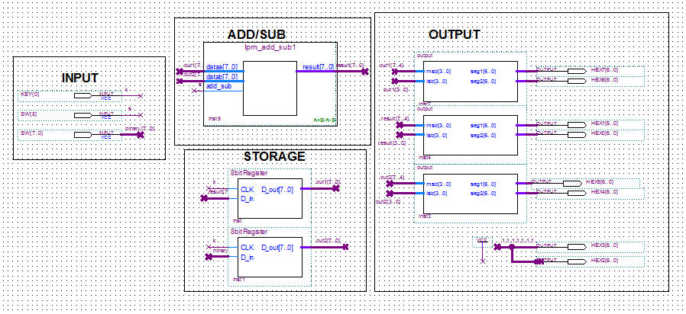

3. Functional behavior requirements

System-level functional requirement #1. When the switches are arranged in binary, the output should display in the 7-segment display in Hex (base 16).

System-level functional requirement #2. When the pushbutton is pressed, the number should increment .

4. Prototype testing plan
The testing procedure consists of the following steps:

1. Initially, all switches are down and the button is un-pushed. None of the LED lights are on meaning the 8-bit binary is equal to 0.

2. Next, the switched are used to count in binary to 255 (base 10). The LEDR’s should light up to illustrate the given binary number.

3. Lastly, the button is then pressed and tested. It should increment the hex number.

5. Result of Testing

When we first tested it, all the calculations were correct except the input couldn’t be changed. It stayed at “FF” which means 255 (the highest 2 bit hex number). We had two registers, when we only needed one, so we took one out. Also, we had two extra HEX displays because we thought we needed to show the accumulator, but that was just the input for the result. After we did that, out circuit still ddidn’t work correctly, it had the same problem. It seemed that all the switches were stuck on high. The final solution was changing the switches; the pin-assignment editor was malfunctioning due to the spread of the switches.

6. Questions

Question #1.
Just like in previous labs, the user can provide the eight-bit input using the switches on the DE2 board.

Question #2.
A debounced pushbutton switch would be a satisfactory input device at the button that adds a value to the accumulator register. The devise is normally active high and generates one active low pulse when the switch is pressed. The circuit will take action when the button is pressed.

Question #3.
An 8 bit binary can converts a max 2 digit hexadecimal number (FF). The output device in the DE2 board that would be most suitable is the 7-segment display.

Question #4.
For design testability, the binary can be displayed using the LEDR’s. 8 would be used to illustrate the 8-bit binary number.

Question #5.
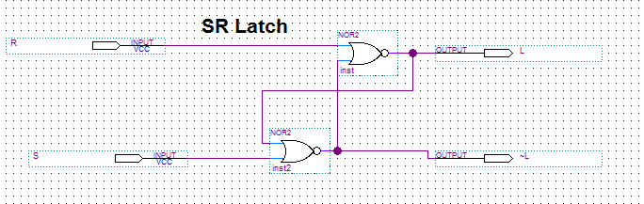
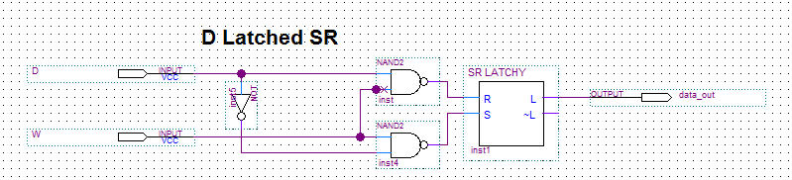
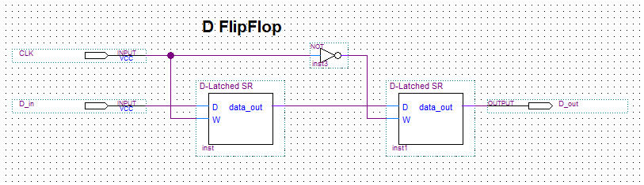
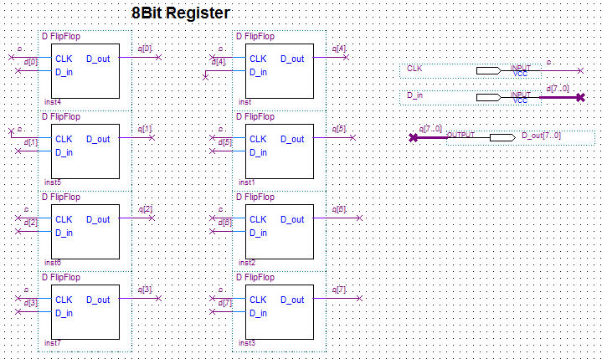

Question #6.
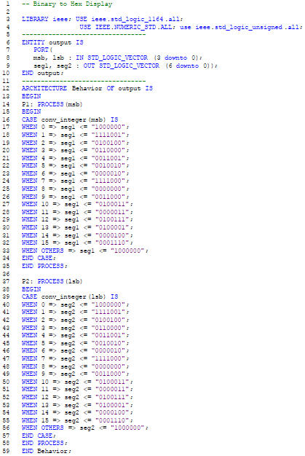
Question #7.
The 8-bit register is built starting with SR latches.The SR latch is built from two cross-coupled NOR gates. The S and R inputs are active high (1) so that the output is latched.

Question #8.
The logic that is needed to build the required D latch functionality on top of the SR latch is adding 2 NAND gates, and one inverter. We need to add a “latched” mode, in which both ~S and ~R are deasserted (1).
Question #9.
Question #10.

7. Conclusion
This assignment was intended to help in the practice with VHDL coding of simple combinational logic modules. By building a working 8-bit clocked data register from scratch in modular design, it helps in the understanding of fundamental concepts of sequential logic. This lab also gives practice at wiring up, simulating, and debugging modular sequential designs using Quartus. Lastly this lab exercise held in my ability to go through a structured design process with all appropriate documentation.

